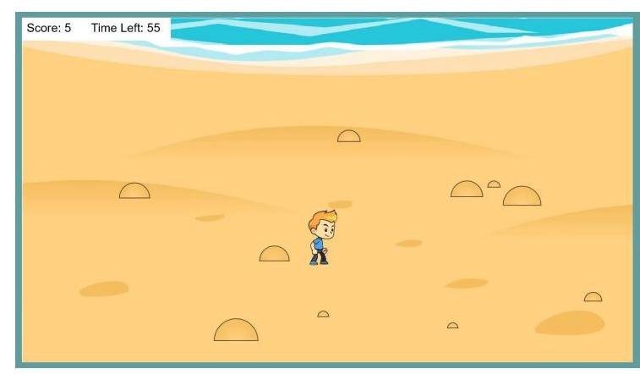
Title:

Description |  | Elements
Duration |  | Elements animation
Description |  | Elements
Duration |  | Elements animation
Description |  | Elements
Duration |  | Elements animation
Description |  | Elements
Duration |  | Elements animation

